
[CSE341] Software Testing, Validation and Verification
PROJECT REPORT

Submitted to
Dr. Islam Elmaddah
Submitted by
Ferass Ahmed Mostafa - 23p0304
Radwa Sayed Ahmed - 24P0145
Sandra Waleed Mohamed - 24P0135

For codes:
https://github.com/ferasahmed285/Banking-System

1.0 Introduction
This project focuses on testing a simplified Banking System that supports client onboarding, deposits, withdrawals, transfers, and administrative workflows. The system also manages account states such as Verified, Suspended, and Closed.
To ensure correctness and reliability, we apply different testing techniques including black-box, white-box, UI, state-based testing, and TDD. These approaches help validate core functionalities, check boundary cases, and verify state transitions.
The goal is to improve software quality by detecting defects early, ensuring consistent behavior, and building confidence in the system's ability to handle real-world banking scenarios.
.

2.0 Files Structure
src
├── main
│ ├── java
│ │ ├── com
│ │ │ ├── Backend
│ │ │ │ ├── DAO
│ │ │ │ │ ├── AccountDAO.java
│ │ │ │ │ ├── ClientDAO.java
│ │ │ │ │ ├── EmployeeDAO.java
│ │ │ │ │ ├── TransactionDAO.java
│ │ │ │ ├── Database
│ │ │ │ │ ├── Data.java
│ │ │ │ │ ├── TestData.java
│ │ │ │ ├── Entities
│ │ │ │ │ ├── Account.java
│ │ │ │ │ ├── Client.java
│ │ │ │ │ ├── Employee.java
│ │ │ │ │ ├── Transaction.java
│ │ │ ├── controllers
│ │ │ │ ├── Admin
│ │ │ │ │ ├── Forms
│ │ │ │ │ │ ├── AdminAccount_FormController.java
│ │ │ │ │ │ ├── AdminTransaction_FormController.java
│ │ │ │ │ ├── Pages
│ │ │ │ │ │ ├── AdminAccount_PageController.java
│ │ │ │ │ │ ├── AdminCustomers_PageController.java
│ │ │ │ │ │ ├── AdminTransaction_PageController.java
│ │ │ │ ├── Client
│ │ │ │ │ ├── Cards
│ │ │ │ │ │ ├── Notification_CardController.java
│ │ │ │ │ │ ├── Transaction_CardController.java
│ │ │ │ │ ├── Forms
│ │ │ │ │ │ ├── DepositMoney_FormController.java
│ │ │ │ │ │ ├── Profile_FormController.java
│ │ │ │ │ │ ├── SendMoney_FormController.java
│ │ │ │ │ │ ├── WithdrawMoney_FormController.java
│ │ │ │ │ ├── Pages
│ │ │ │ │ │ ├── Dashboard_PageController.java
│ │ │ │ │ │ ├── Transaction_PageController.java
│ │ │ │ │ ├── ForgotPassword_PageController.java
│ │ │ │ │ ├── Login_PageController.java
│ │ │ │ │ ├── Signup_PageController.java
│ │ │ │ ├── AlertBox.java
│ │ │ │ ├── BankingSystem.java
│ │ │ │ ├── Date.java
│ │ │ │ ├── SceneController.java
│ │ │ ├── module-info.java
│ ├── resources
│ │ ├── Frontend
│ │ │ ├── fxml
│ │ │ │ ├── Admin
│ │ │ │ │ ├── Forms
│ │ │ │ │ │ ├── AdminAccount_Form.fxml
│ │ │ │ │ │ ├── AdminTransaction_Form.fxml
│ │ │ │ │ ├── Pages
│ │ │ │ │ │ ├── AdminAccount_Page.fxml
│ │ │ │ │ │ ├── AdminCustomers_Page.fxml
│ │ │ │ │ │ ├── AdminTransaction_Page.fxml
│ │ │ │ ├── Client
│ │ │ │ │ ├── Cards
│ │ │ │ │ │ ├── Notification_Card.fxml
│ │ │ │ │ │ ├── Transaction_Card.fxml
│ │ │ │ │ ├── Forms
│ │ │ │ │ │ ├── DepositMoney_Form.fxml
│ │ │ │ │ │ ├── Profile_Form.fxml
│ │ │ │ │ │ ├── SendMoney_Form.fxml
│ │ │ │ │ │ ├── WithdrawMoney_Form.fxml
│ │ │ │ │ ├── Pages
│ │ │ │ │ │ ├── Dashboard_Page.fxml
│ │ │ │ │ │ ├── Transaction_Page.fxml
│ │ │ │ │ ├── ForgotPassword_Page.fxml
│ │ │ │ │ ├── Login_Page.fxml
│ │ │ │ │ ├── Signup_Page.fxml
│ │ │ │ ├── Styles.css
├── test
│ ├── java
│ │ ├── AccountBlackBoxTest.java
│ │ ├── AccountStateTest.java
│ │ ├── AccountWhiteBoxTest.java
│ │ ├── CreditScoreFeatureTest.java

3. Section A — Black-Box Testing
Black-box testing exercises deposit(), withdraw(), and the (unimplemented) transfer() feature purely against their specified input/output behavior, without reference to internal code structure. Equivalence Partitioning (EP) and Boundary Value Analysis (BVA) are used to select a small, high-yield set of inputs.

3.1 Equivalence Partitioning
deposit(amount)
Class | Partition | Representative Value | Expected
EP1 | Negative amount | -100 | false (invalid)
EP2 | Zero amount | 0 | false (invalid, amount<=0)
EP3 | Valid positive amount, account not Closed | 250 | true, balance increases
EP4 | Any amount, status = Closed | 250 | false (blocked regardless of amount)

withdraw(amount)
Class | Partition | Representative Value | Expected
EP5 | Amount ≤ current balance, status = Verified | 50 (balance=1000) | true, balance decreases
EP6 | Amount > current balance, status = Verified | 5000 (balance=1000) | false (overdraft prevented)
EP7 | Any amount, status = Suspended | 50 | false (blocked by status)
EP8 | Any amount, status = Closed | 50 | false (blocked by status)
transfer(amount, targetAccount) — inferred from GUI/spec
transfer() is referenced in the GUI and status-action tables but no source was provided. Test design assumes it composes a withdraw() on the source account and a deposit() on the target account, and is additionally disabled at the UI layer whenever status ≠ Verified (see Section 4).
Class | Partition | Representative Value | Expected
EP9 | Valid transfer, sufficient funds, both accounts Verified | 100 | true, source -100 / target +100
EP10 | Transfer amount exceeds source balance | 5000 | false, no balance change on either account
EP11 | Source account Suspended or Closed | 100 | false / control disabled
EP12 | Target account Closed | 100 | false, rejected before crediting

3.2 Boundary Value Analysis
BVA targets the edges of the numeric ranges identified above: the zero/negative boundary for deposit, and the balance-equality boundary for withdraw.
Test ID | Method | Input | Boundary | Expected Output
BV01 | deposit | amount = -0.01 | just below 0 | false
BV02 | deposit | amount = 0 | the boundary itself | false
BV03 | deposit | amount = 0.01 | just above 0 | true
BV04 | withdraw | amount = balance - 0.01 | just below balance | true
BV05 | withdraw | amount = balance | exactly at balance | true (allowed, drains to 0)
BV06 | withdraw | amount = balance + 0.01 | just above balance | false (overdraft)

3.3 Black-Box Test Case Table
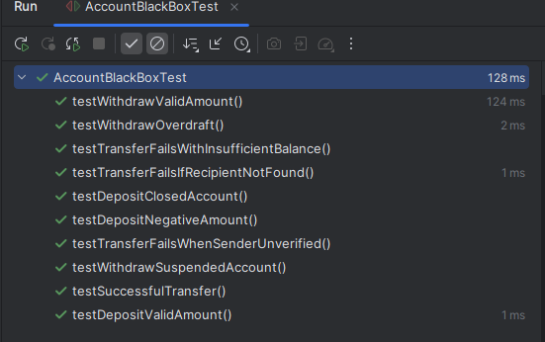
Extending the three seed cases given in the project brief (BB01–BB03) with the partitions and boundaries above:
ID | Input | Preconditions | Expected Output | Notes
BB01 | deposit(-100) | status = Verified | false | Invalid amount (EP1)
BB02 | withdraw(50) | status = Verified, balance ≥ 50 | true | Blocked if Suspended (EP5)
BB03 | withdraw(500) | status = Verified, balance = 100 | false | Overdraft prevention (EP6)
BB04 | deposit(0) | status = Verified | false | Zero boundary (BV02)
BB05 | deposit(250) | status = Closed | false | Deposit blocked once Closed (EP4)
BB06 | withdraw(50) | status = Suspended | false | Suspended cannot withdraw (EP7)
BB07 | withdraw(balance) | status = Verified, balance = 300 | true, new balance = 0 | Exact-balance boundary (BV05)
BB08 | transfer(100, acct2) | both accounts Verified, balance ≥ 100 | true | Composed of withdraw+deposit (EP9)
BB09 | transfer(5000, acct2) | source balance = 1000 | false | Exceeds source balance (EP10)

4. Section B — White-Box Testing
White-box testing inspects the internal decision logic of deposit() and withdraw() (standing in for TransactionProcessor's core validation paths, per the assumption in Section 1) to derive control flow graphs, compute cyclomatic complexity, and design tests that achieve full branch coverage.

4.1 Control Flow Graph — deposit()
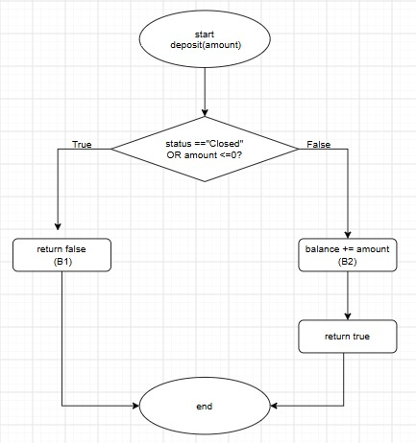
Cyclomatic complexity: V(G) = E − N + 2 = 6 − 6 + 2 = 2, matching the 2 independent paths through the method (reject vs. accept).

4.2 Control Flow Graph — withdraw()
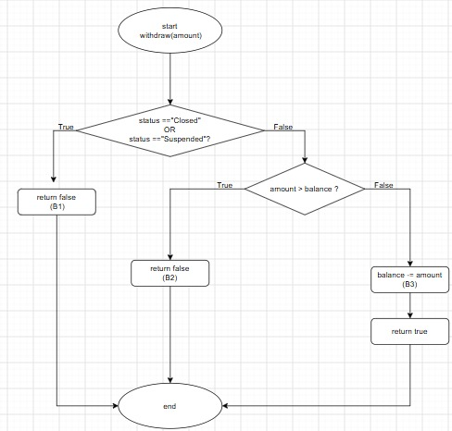
Cyclomatic complexity: V(G) = E − N + 2 = 9 − 8 + 2 = 3, matching the 3 independent paths through the method.

4.3 Branch / Decision Coverage Table
Method | Branch | Condition to trigger | Covering Test
deposit | B1 | status=="Closed" OR amount<=0 → true | BB05, BB04, BB01
deposit | B2 | status=="Closed" OR amount<=0 → false | BB08 setup (plain deposit of 250 while Verified)
withdraw | B1 | status Closed/Suspended → true | BB06
withdraw | B2 | status ok, amount > balance → true | BB03
withdraw | B3 | status ok, amount ≤ balance → true | BB02, BB07
All 5 branches across the two methods are exercised by tests already listed in Section 2, giving 100% branch coverage for deposit() and withdraw() with no additional test cases required — this is a deliberate design goal, since black-box partitions were chosen to also satisfy white-box branch coverage.

5. Section C — UI Testing
UI testing targets the Client Dashboard: text fields (Client Name, Account Number, Balance), action buttons (Deposit, Withdraw, Transfer, View Statement), the status label, and the notification box. Checks cover input validation, state-dependent button availability, and message correctness.
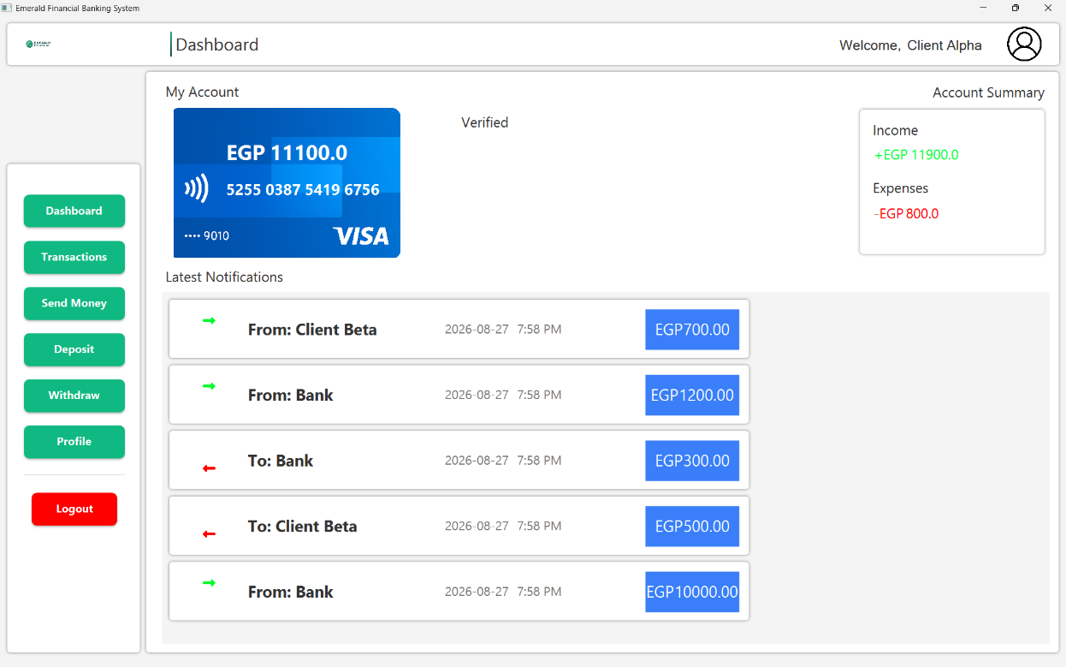

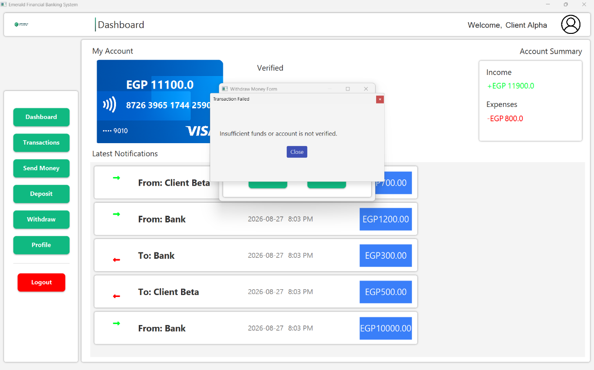

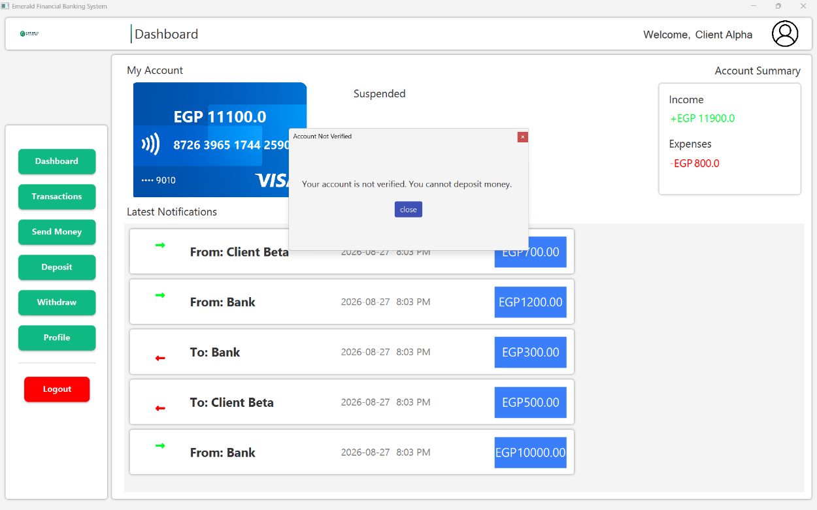

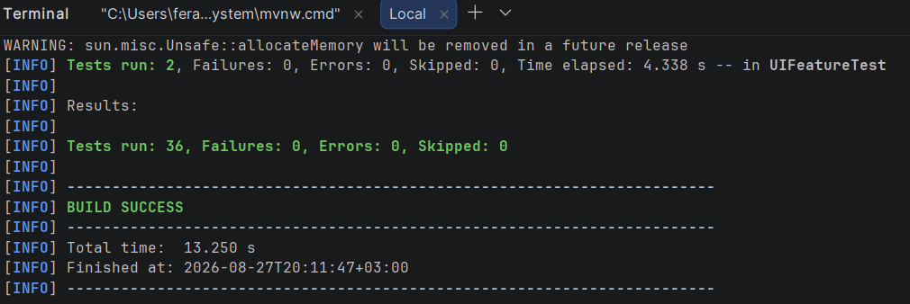

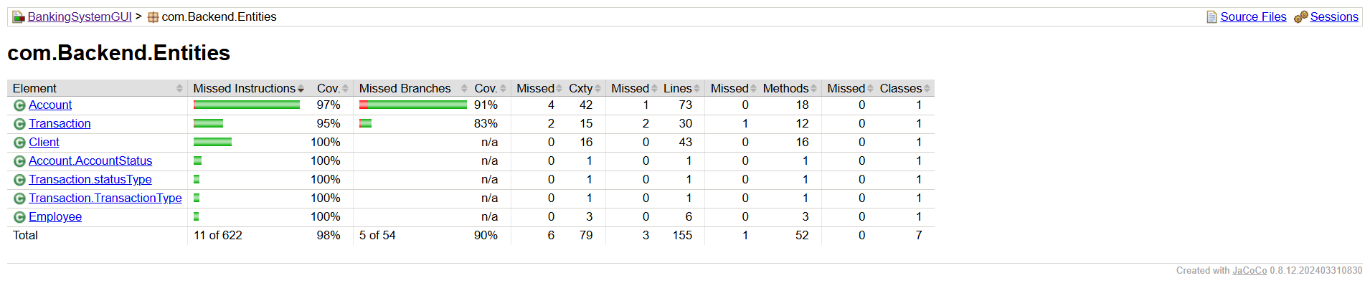

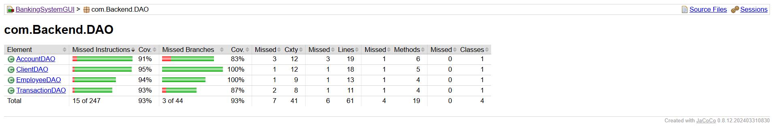

Admin
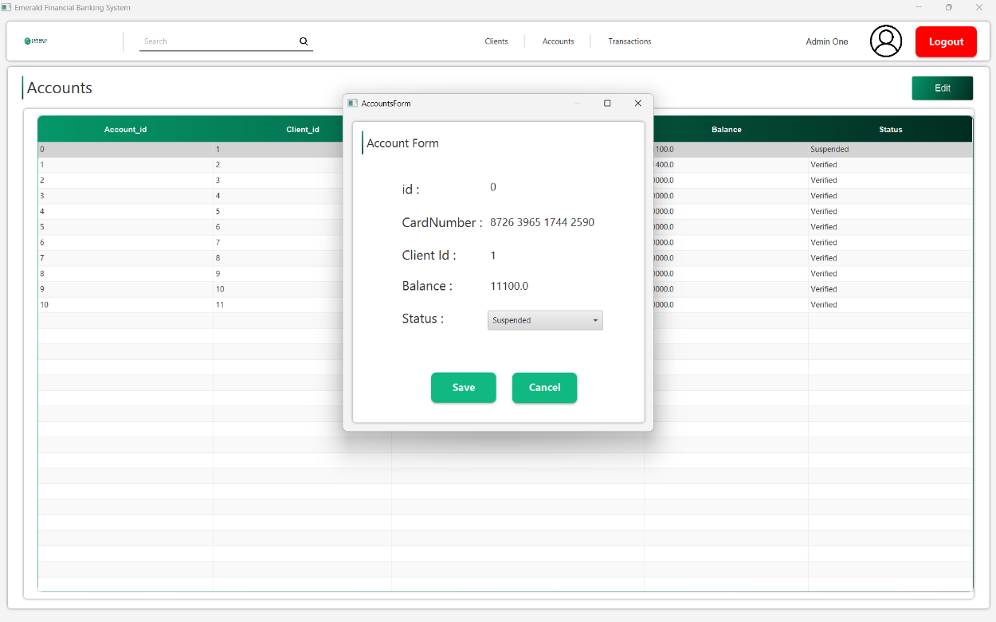

6. Section D — State-Based Testing
State-based tests are derived directly from the Account Lifecycle state diagram: Unverified → Verified → Suspended → Closed, with transitions Verify, Violation, AdminAction, and Appeal (Suspended → Verified).
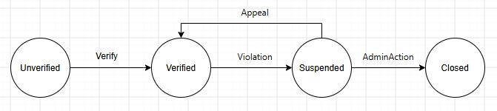

6.1 State Transition Matrix
State | Deposit | Withdraw | Transfer | Verify | Violation | Appeal | AdminAction
Unverified | illegal | illegal | illegal | Verified | Not apply | Not apply | Not apply
Verified | allowed | allowed | allowed | Not apply | Suspended | Not apply | Closed
Suspended | illegal | illegal | illegal | Not apply | Not apply | Verified | Closed
Closed | illegal | illegal | illegal | Not apply | Not apply | Not apply | Not apply (terminal)

6.2 Test Cases: Deposit / Withdraw
ID | Precondition | Action | Input | Expected | Notes
SB01 | status = "Closed" | deposit() | 100 | returns false, balance unchanged | Directly covered by the Closed check in deposit()
SB02 | status = "Closed" | withdraw() | 50 | returns false, balance unchanged | Directly covered by the Closed check in withdraw()
SB03 | status = "Suspended" | withdraw() | 50 | returns false, balance unchanged | Directly covered by the Suspended check in withdraw()
SB04 | status = "Suspended" | deposit() | 100 | should return false per spec | Bug: deposit() does not check Suspended — see flag below
SB05 | status = "Verified" | deposit() | 100 | returns true, balance increases | Baseline positive case
SB06 | status = "Verified" | withdraw() | ≤ balance | returns true, balance decreases | Baseline positive case
SB07 | status = "Unverified" | deposit() | 100 | should return false per spec | Bug: deposit() does not check Unverified
SB08 | status = "Unverified" | withdraw() | 50 | should return false per spec | Bug: withdraw() does not check Unverified
Bug flag: deposit() only checks status.equals("Closed").

6.3 Test Cases: Transfer
ID | Precondition | Action | Input | Expected | Notes
SB09 | status = "Suspended" | transfer() | any | blocked | No transfer() method exists on Account — test at TransactionProcessor/controller level, or flag as untestable gap
SB10 | status = "Closed" | transfer() | any | blocked | Same as above

6.4 Test Cases: State Transitions
ID | Precondition | Action | Input | Expected | Notes
SB11 | status = "Unverified" | setStatus("Verified") | — | status becomes "Verified" | Verify transition, valid path
SB12 | status = "Verified" | setStatus("Suspended") | — | status becomes "Suspended" | Violation transition, valid path
SB13 | status = "Suspended" | setStatus("Verified") | — | status becomes "Verified" | Appeal transition, valid path
SB14 | status = "Verified" or "Suspended" | setStatus("Closed") | — | status becomes "Closed" | AdminAction transition, valid path
SB15 | status = "Closed" | setStatus("Verified") | — | should be rejected — Closed is terminal | ⚠ Bug: setStatus() has no validation and will reopen a closed account
Bug flag: setStatus() performs zero validation.

7. Section E — Test-Driven Development: Client Credit Score Check
This section simulates adding a new feature — a Client Credit Score Check that gates certain actions (e.g. raising a transfer limit or approving a loan add-on) — using the TDD red-green-refactor cycle: tests are written first, then the minimal implementation is added to satisfy them.

7.1 Test Plan
- Feature: CreditScoreChecker.isEligible(int score, double requestedLimit) returns true only when the score meets a minimum threshold for the requested limit tier.
- Scope: unit tests only for this iteration; integration with TransactionProcessor is out of scope.
- Threshold rules under test: score < 500 → never eligible; 500–699 → eligible for limits up to 5,000; 700+ → eligible for any limit up to 50,000.
- Edge cases: score exactly at a threshold boundary (500, 700), requestedLimit exactly at a tier cap, negative or zero score (invalid input).

7.2 Expected Behavior (from the tests, before implementation exists)
Test ID | score | requestedLimit | Expected
TDD01 | 450 | 1,000 | false — below minimum score
TDD02 | 500 | 5,000 | true — boundary score, boundary limit
TDD03 | 500 | 5,001 | false — over limit for this tier
TDD04 | 699 | 5,000 | true — top of mid tier
TDD05 | 700 | 50,000 | true — top tier, max limit
TDD06 | 700 | 50,001 | false — exceeds max allowed limit
TDD07 | -10 | 1,000 | false — invalid score rejected
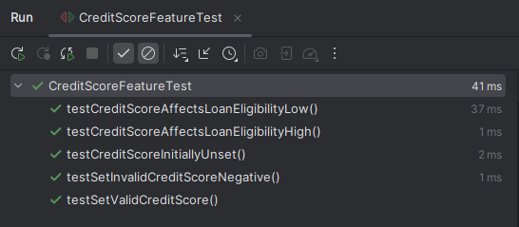

8. Conclusion
Across all five testing strategies, the account status field is the single control point most tests converge on: nearly every illegal action in the system (deposit/withdraw/transfer while Suspended or Closed) is really the same guard condition being checked from a different angle — backend validation, UI button state, and state-machine legality. Concentrating extra scrutiny on that one field, and on the numeric boundaries around zero and current balance, accounted for the majority of meaningful test cases in this project relative to the effort spent designing them.

